Temperature Control
In order to provide more accurate control, two type “J” thermocouple (T/C) need to be input into one controller.
The controller must use T/C “A” only for sensing until the differential between T/C “A” and T/C “B" exceeds 45 °F. At this point, the controller must then switch over to T/C “B” for its temperature input. Unfortunately, the controller does not have the ability to make this key T/C exchange by itself.
In order to accomplish this input switching, we will use three M-System units (2 pcs. M2TS / 1 pc. AYDV) as shown in the figure. The M2TS units convert the T/C signal to linear 1-5V dc signals which are then fed into the AYDV deviation alarm unit. The setpoint for the AYDV is set at 10% which corresponds to the 45°F differential temperature between our T/Cs. By wiring the positive (+) outputs of each M2TS unit to each pole of the AYDV’s output relay and then wiring the negative (-) outputs together to the negative (-) side of the controller input, the automatic switching function for the controller is accomplished when the differential is exceeded.
Note: This application solution can be applied to pressure transducers, frequency transmitters for conveyor or flowmeter switching, or various other applications that are present throughout the world.
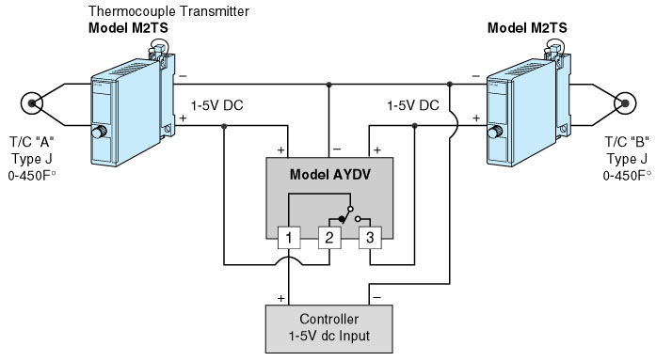
M-System has flexible solutions to meet your specific application and requirements. Consult our Signal Conditioners Data Library. 

