
What are the major characteristics of Model M2PP?

M-System’s Model M2PP is designed specifically to accept mechanical contacts, open collectors or voltage pulses (frequencies) and provide up to 2000V AC of isolation between input, output and power. The output type can be any choice ranging from mechanical contacts with a 30Hz maximum to a high frequency 24-volt pulse at 10,000Hz maximum. An on-board sensor excitation power supply eliminates the need to add an external supply in the application.
The model M2PP is also a convenient way to convert one frequency input type to another. For example, a dry contact input may be converted to a 5-volt voltage pulse output at the same frequency. The input frequency is always repeated at the output, although the pulse type may be different. The difference between model M2PP of Mini-M series and model PP of M-Unit series are model M2PP’s size and price are more economical and output logic can be specified.
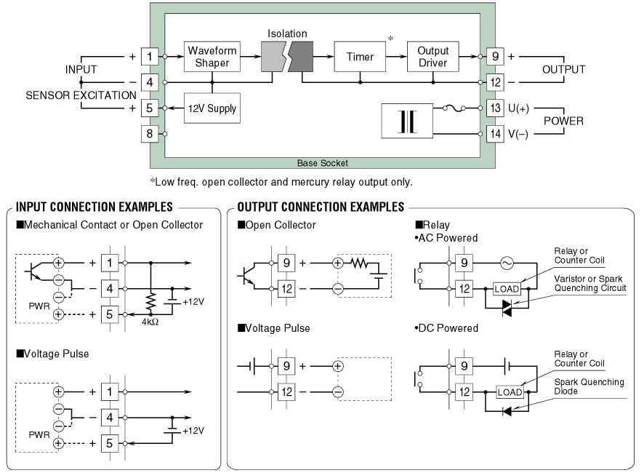
M-System has flexible solutions to meet your specific application and requirements. Consult our Signal Conditioners Data Library. 

