
I need to indicate flow pulse signals (10,000 pulses/hour) at two independent integrating counters. Maximum input to each counter is 500 pulses/hour.

You have to first scale the flow signal of 10,000 pulses/hour down to 500 pulses/hour (1), and then distribute the pulse output to two counters (2). See the system configuration below.
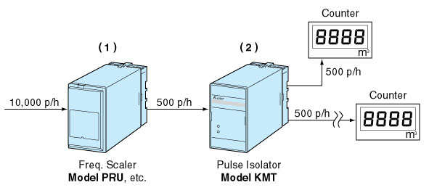
- Frequency Scaler (model PRU, KPRU, etc)
In order to convert 10,000 pulses into 500, set the scaling factor to 0.5 x 10⁻¹. You can set the factor with front-mounted rotary DIP switches.
Input: mechanical contact, open collector or voltage pulse
Output: open collector, relay contact or voltage pulse
Scale: 0.9999 x 10⁰ – 0.0001 x 10⁻⁶ (PRU/KPRU)
- Pulse Isolator (model KMT)
It provides two isolated contact output signals.
Input: mechanical contact, open collector
Output: relay contact, open collector
M-System has flexible solutions to meet your specific application and requirements. Consult our Signal Conditioners Data Library. 

