Frequency Transmitter Model JPA Application
The positive displacement flowmeter handles viscosities up to 1000000 cP, up to 1000 psig operating pressure with up to 1000:1 turndown. It uses two rotating impellers driven by the liquid flowing through the meter to generate a pulsed output signal. Magnets imbedded in the impellers activate a non-intrusive sensor which creates a signal proportional to the flow rate.
Application uses M-System model JPA Field Programmable Frequency to Analog Transmitter. The analog output signal is directly proportional to its linear or non-linear input frequency. One of the features that make the JPA attractive is the 16 points of linearization, standard JPA feature, that is programmable with hand held programmer PU-2. The positive displacement flowmeter has a linearity of 0.5% over the upper 80% of span. When their customers require even greater linearity the flowmeter and JPA combination produce 0.1% linearity over the full turndown range.
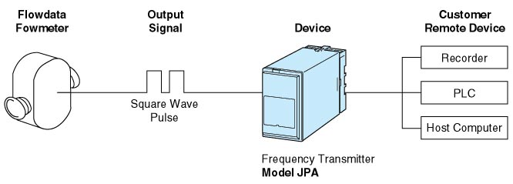
M-System has flexible solutions to meet your specific application and requirements. Consult our Signal Conditioners Data Library. 

