
Will the model MTD work according to the following specs?
Input: 4-20 mA DC
Output: 20 sec. Cycle, 24 V pulse
At 4 mA: 1 sec. ON, 19 sec. OFF
At 20 mA: 19 sec. ON, 1 sec. OFF
Power supply: 230 V AC

Yes, your specifications are exactly within M-System’s standard specs.
See the figure below. The frame duration in your application is 20 seconds, ON times at 0% and 100% are 5% and 95% of the frame.
The “ON” time or output pulse duration of the MTD unit is proportional to the amplitude of the input signal. The frame duration is adjustable from 0.1 up to 102.4 seconds, and the ON time duration at 0% and 100% inputs are adjustable up to 20%.
The MTD is useful for an ON/OFF proportioning control device to operate solenoid valves or other similar final control elements, and as a data transmitter in combination with the receiver model JTDA.
Application areas for this type of pulse control: sugar refining, pulp and paper, food processing, metals and mining, water treatment, liming process, bleaching, cream and butter processing, ore flotation process, flocculating.
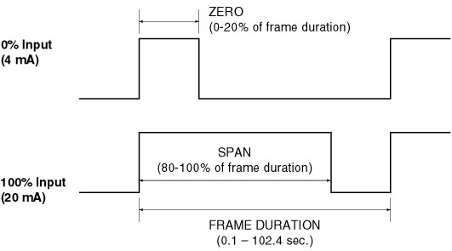
M-System has flexible solutions to meet your specific application and requirements. Consult our Signal Conditioners Data Library. 

