
I’m looking for a product, which can add two types of flow. Besides, I need thin unit because we don’t have much room in the existing cabinets. Is there a suitable unit for this application?

The M-System Model M2ADS Adder fits this application perfectly. The M2ADS receives two DC inputs and provides an output proportional to the addition of the inputs. Equation is as shown below;
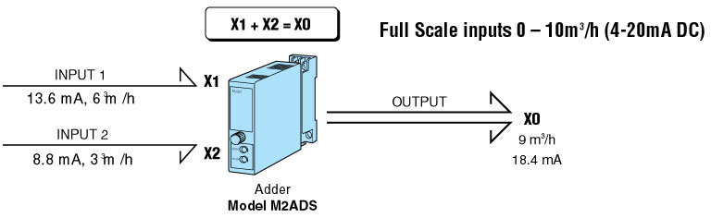
Please take notice that full scale for input 1 and input 2 must be same flow volume. Forcibly limited is up to 120% respectively when the input signal is out of range. We also provide a subtractor, model M2SBS from Mini-M Series. It is suitable for the applications such as calculating temperature of flow differences.
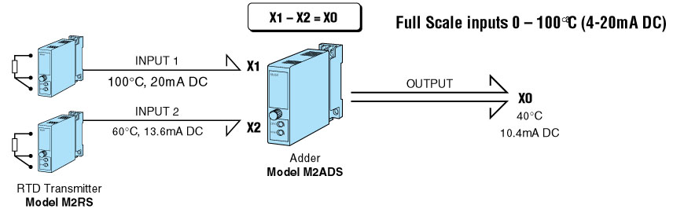
M-System has flexible solutions to meet your specific application and requirements. Consult our Signal Conditioners Data Library. 

