DC Watt Monitor
It is quite common to find AC watt transducers and monitors to meet most requirements. However, we were asked to supply a DC wattage monitor system for a client. Since this was not a standard unit, several units were used to accomplish it.
The first M2VS unit converts and isolates the 0-30 Vdc signal, while the second M2VS unit converts and isolates the 0-100 mVdc signal from the shunt resistor.
The math function model M2MLS performs the V x I calculation and outputs a 1-5 Vdc sending to the 44AV1 panel meter. The 44AV1 is used to display the continuous DC wattage value as well as having alarm setpoints alert when the motor is potentially getting ready to burn out or shut down, requiring immediate maintenance.
In a 24-hour continuous process, an automated system like this can save down time as well as money due to product loss. Applications are various depending on wherever DC motors are used.
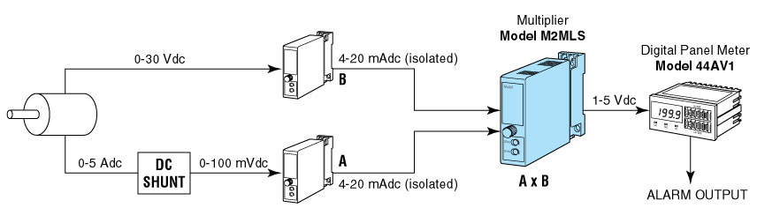
M-System has flexible solutions to meet your specific application and requirements. Consult our Signal Conditioners Data Library. 

