
How do I determine wattage from a DC source?

M-System’s MLS & M2MLS models perform a multiplication of two input signals to determine wattage by:
- The MLS and M2MLS accept direct voltage and direct current inputs.
- By multiplying the two outputs, the unit produces an output indicating the wattage of the supplied input.
Cost effective: As dedicated ‘one function’ units, MLS and M2MLS are cost effective solutions when the customer only requires a multiplication function. In contrast, the Math Function Model ‘JF’ can also perform multiplication, however MLS is approximately 20% less expensive than JF and the soon to be released M2MLS will be even more economical. However, with regard to accuracy MLS and M2MLS at ±0.2% do not match JF at ±0.1%.
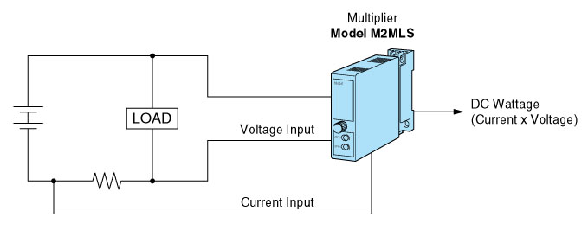
M-System has flexible solutions to meet your specific application and requirements. Consult our Signal Conditioners Data Library. 

