
I would like to determine the ratio of air and fuel flow for combustion control in order to improve the efficiency. How do I get this ratio?

To determine the ratio of air and fuel flow, we have to divide the fuel flow by the air flow. M-System's M2DIS model performs a division of two input signals and provides an output proportional to the division of the inputs.
Other than the combustion control application, you can also find an application for M2DIS to determine the ratio of two materials such as blending system of two materials.
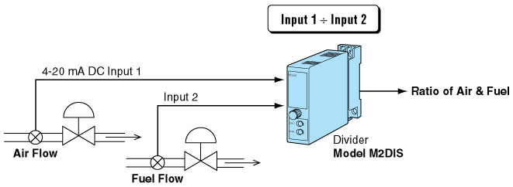
M-System has flexible solutions to meet your specific application and requirements. Consult our Signal Conditioners Data Library. 

