
I have two signals. When one of them multiplied with a certain factor exceeds another signal, I need an alarm.


Between two signals A and B, connect the signal A to be multiplied with a factor to our Ratio Transmitter (model: M2REB) to convert an output C. The Ratio Transmitter can also add a bias (-100 to +100% of the input span) to the input signal as well as a ratio (0.5-3.0).
Then connect the signal B as reference input and the signal C as measured input with our Deviation Alarm (model AYDV). When the deviation (signal C – signal B) exceeds a setpoint value, the Deviation Alarm provides an alarm output. (Refer to the Figure.) The alarm setpoint adjustable range is -50 to +50% of the span (4V) of the reference input (1- 5Vdc). For example, if the setpoint is set to +5%, an alarm is output when the signal C is 5% (0.2V) more than the signal B. The Deviation Alarm has two alarm setpoints to output two independent alarms.
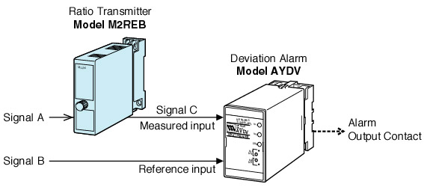
M-System has flexible solutions to meet your specific application and requirements. Consult our Signal Conditioners Data Library. 

