
I’m looking for a product that can be used for ratio control of flow but need to change the ratio frequently. Without using a tester or a screwdriver, is there any product to match my request?

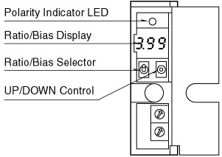
M-System provides a variety ratio/bias transmitters and recommends you Model M2REB to meet your requirement.
The Model M2REB is an output bias type and you can adjust both ratio and bias adjustments from the front panel. Adjustments are easy. Press UP/DOWN control until the display shows a desired set value. The ratio adjustment is enabled from 0.1 to 4.00 and bias adjustment is enabled from -100 to 100%.

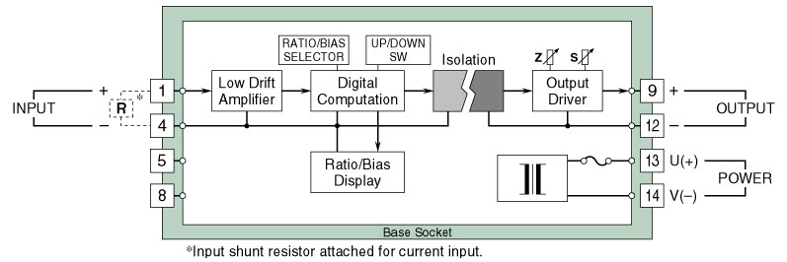
Circuit Diagram of model M2REB
M-System has flexible solutions to meet your specific application and requirements. Consult our Signal Conditioners Data Library. 

