
I am looking for a product that can be used for ratio control of air/fuel flows and I periodically have to change the ratio. Is there any product that meets my requirement?

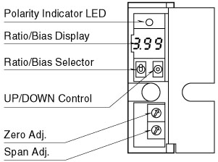

We recommend you to use a Ratio/Bias transmitter model M2RTS. The model M2RTS is an input bias type and you can adjust both ratio and bias with UP/DOWN switch while watching the ratio/Bias display incorporated in the front panel. Therefore you do not need to use a tester or a screwdriver. Adjustments are easy. The ratio adjustment is enabled from 0.1 to 4.00 and bias adjustment is enabled from –100 to 100%.
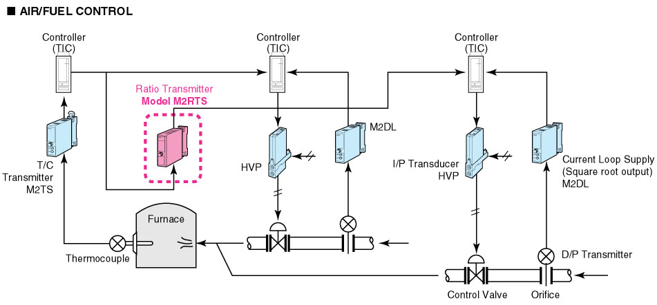
M-System has flexible solutions to meet your specific application and requirements. Consult our Signal Conditioners Data Library. 

