
In my current PID controller setup, when a contact signal changes the Set Value (SV) in the control loop, the PID process controller responds with a sudden increase of the Manipulated Value (MV), causing instability in the control process. How can I make any controller MV responses to SV changes more gradual?

Connect the M2CRS Ramp Buffer unit’s input to the PID process controller’s output contact point and use the M2CRS to slow down and smooth out the sudden change in the controller response.
M2CRS unit:
The M2CRS is called a ‘Ramp Buffer’ because it limits the output rate of change once the rate of the input rate of change exceeds the preset value (see illustration).
The M2CRS is a unique signal conditioner in this respect and also allows a great deal of flexibility, with the rate of change period being adjustable up to 40 seconds via a front mounted pot.
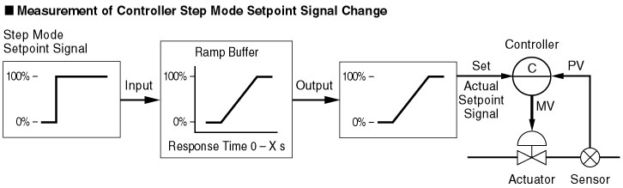
Other useful features include:
- Universal power input (85 - 264V AC and 11 - 27V, 110V DC)
- CE marking for 24V DC
- Isolation: Input to Output to Power
- Zero and Span adjustment of ± 0.5%
