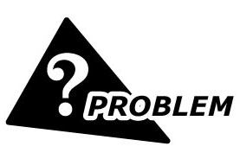
We have a mixing machine for adhesives. When the rotating speed of its motor becomes too high, the motor is heated and turns to dangerous condition.
Can you tell us how to limit the maximum rotating speed by a remote signal?
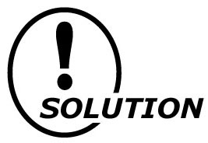
The High/Low Selector, model M2SES-1A4-R, connected as in the figure below provides a solution. The M2SES chooses lower of two signals; Input 1 is the motor control signal, and Input 2 is the desired maximum limit.
As far as the control signal value (input 1) is lower than the maximum limit (input 2), the M2SES outputs the control signal. However, when it becomes higher than the limit, the M2SES outputs the maximum limit signal. See the figure below, it shows the output characteristics of the M2SES when the limit signal 18.4 mA is provided to input 2 terminals.
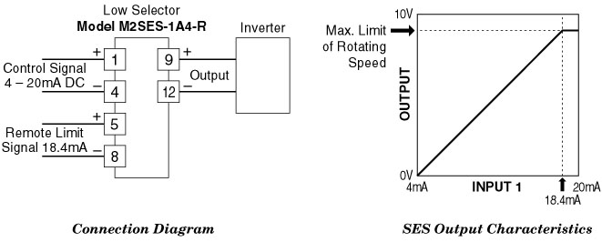
M-System has flexible solutions to meet your specific application and requirements. Consult our Signal Conditioners Data Library. 

