
Due to the common mode noise problem, we urgently need isolation for the 4-20mA current loop. But we do not have an isolator right now. And we have an isolated type High/Low Selector (model: M2SES, inputs 4-20mA, output 4-20mA) as spare parts.
From the specification sheet of this unit, we guess that we can temporary use this unit as an isolator Is it correct?

First of all, check full model of the unit that you have. The answer varies with High Selector, or Low Selector. M2SES-2AA-_ is a High Selector and M2SES-1AA is a Low Selector.
If you have the High Selector unit, the answer is Yes. As model M2SES is isolated between input-output-power, you can use this as an isolator too. But this unit has two inputs because it selects a High signal between two inputs. Therefore in order to use this unit as an isolator, you have to make wiring properly in accordance with the connection diagram below.
If you have the Low Selector, unfortunately it is impossible for you to use this unit as an isolator. However be noticed that as M-System can meet your delivery schedule.
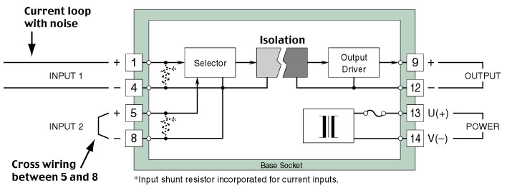
M-System has flexible solutions to meet your specific application and requirements. Consult our Signal Conditioners Data Library. 

