Peak Monitoring – Applying the Peak/Hold Function Transmitter M2PHS
In this application, a 4 to 20 mAdc signal represents a process variable that has normally increasing characteristics. However, at any given time the signal could reach its peak and then suddenly decrease. The peak value of the signal is critical to the main control loop.
A contact closure is needed to shut down the process and energize and annunciator if the signal drops below the peak value by a specified amount. The combination of the model M2PHS and the model AYDV can provide this control
The diagram below shows the M2PHS input signal as the “reference” input to the model AYDV, and the output of the M2PHS as the “measuring” input to the AYDV. As the 4 to 20 mA signal increases, the input and output of the M2PHS are identical. These two equal signals are sensed by the AYDV which causes the output relay is then tripped (ALARM).
When the 4 to 20 mA signal starts decreasing, the M2PHS output is held at the “peak” value causing a deviation to occur between it and the “measuring” input. When the deviation reaches the set value on the AYDV, the output relay is then tripped (ALARM).
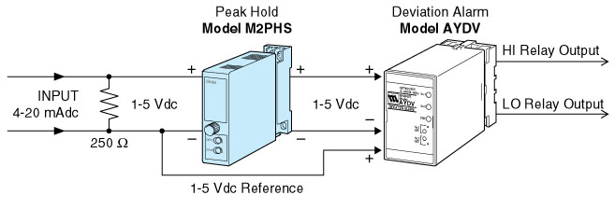
M-System has flexible solutions to meet your specific application and requirements. Consult our Signal Conditioners Data Library. 

