
I have an application where my input signal to a signal conditioner is constantly rising and falling. How can I maintain the output from the signal conditioner so that it will only increase in response to a rising value?

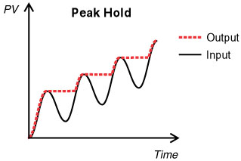
M-System’s M2PHS - Peak Hold model will fulfill your requirements. The M2PHS - Peak Hold Transmitter can maintain a rising peak output indefinitely upon a ‘peak hold’ order, given by opening the circuit between terminals 5 and 8. Upon receiving the ‘peak hold’ order, the transmitter will only respond to a changing input signal if the signal is higher than all previous signals. The ‘peak hold’ function is maintained until the circuit between terminals 5 and 8 is closed.
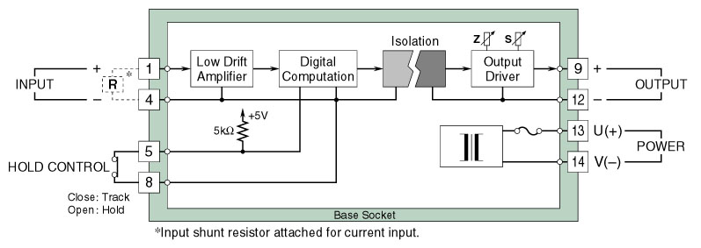
Circuit diagram of model M2PHS
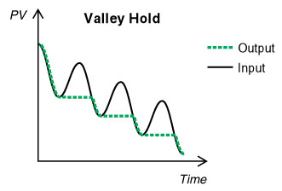
Valley Hold: The Model M2PHS can also be configured to perform a ‘valley hold’ function. The logic of ‘valley hold’ is the same as that of peak hold except that the output signal will only change in response to an input signal that is lower than all previous input signals.
Application examples:
- Maximum and Minimum Temperature
- Maximum Power Usage
- Maximum Pollution Level
M-System has flexible solutions to meet your specific application and requirements. Consult our Signal Conditioners Data Library. 

