
Now we are measuring the current of a motor by a signal conditioner via CT (current transformer). This signal (4-20 mA) goes to a telemetering device to transmit to a control room. But in the event when the motor is switched on, the signal conditioner outputs more than 20 mA due to a rush current. That recognizes that the signal is as motor default.
Is there any good idea to avoid the over range output?

By placing a Limiter model M2LMS between a signal conditioner and telemetering device, you can avoid above situation.
The M2LMS has a function to prevent a DC output signal from going above or below preset values. High and Low limits are independently adjustable over entire range.
As for another application, you can use Limiter for securing the minimum fuel flow in a combustion control loop.
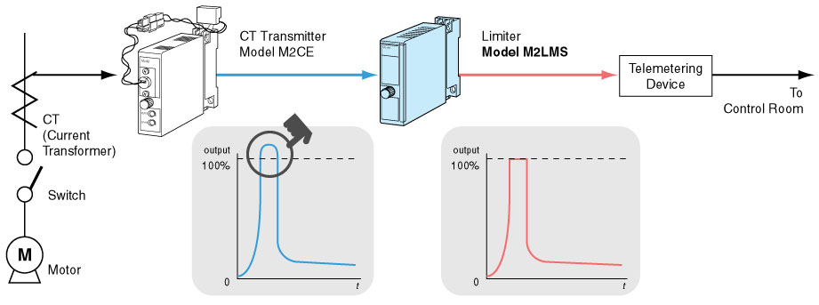
M-System has flexible solutions to meet your specific application and requirements. Consult our Signal Conditioners Data Library. 

