Split Range Control – Applying Limiter M2LMS
There is a 4 to 20 mAdc signal that must be split into two separate ranges to operate two valves, Valve A and B. Valve A is operated with 4 to 12 mAdc, while B is operated with 12 to 20 mAdc.
To solve this problem, you can use two Limiters model M2LMSs. Set high limit to 12 mA, 50% of full-scale for Valve A and low limit to the same value for B.
However the control signal changes below 12 mA, a constant 12 mA signal is provided to Valve B, and over 12 mA, it is provided to Valve A.
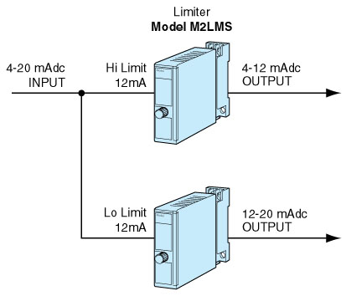
M-System has flexible solutions to meet your specific application and requirements. Consult our Signal Conditioners Data Library. 

