
I want to adjust zero point by remote contact signal. Do you have a suitable transmitter?


M-System’s Track/Hold model M2AMS is suitable for your requirement. Refer to the figure below for the wiring.
The Track/Hold model M2AMS outputs the isolated input signal at the terminals 1 and 4 when the hold terminals (terminal No. 5 and 8) are short-circuited. And it outputs the signal held when the hold terminals are open.
Connect as shown in the figure, and the voltage (current) between A and B will be 0 while the hold terminals are short-circuited. Then when they are open, the variation after the open command will be output between A and B, which can be used to adjust the zero point. However the output signal will be without bias. And if the input signal decreases after the terminals 5 and 8 are open, the output polarity (+, -) will be reversed.
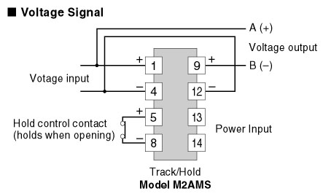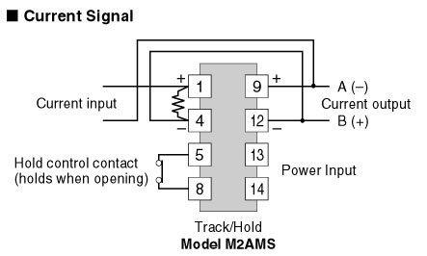

M-System has flexible solutions to meet your specific application and requirements. Consult our Signal Conditioners Data Library. .

