
How can I maintain a specific output from a signal conditioner at certain deliberate times?

The M2AMS – Track/Hold signal conditioner can maintain a specific output indefinitely upon a ‘hold’ order, given by opening the circuit between terminals 5 and 8. Upon receiving the ‘hold’ order, the signal conditioner will produce a constant output signal until the circuit between terminals 5 and 8 is closed.
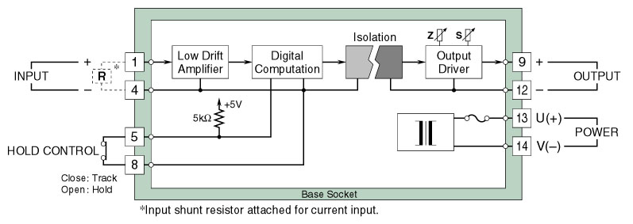
Circuit diagram of model M2AMS
Application Example:
Valve Aperture Hold – in a heating/drying system the M2AMS can be used to record the final fuel valve aperture when a control system error occurs. In this case, the system error would cause the contact relay connected to terminals 5 and 8 to open, thereby maintaining the final measured value of the valve aperture.
