
We are now using the potentiometer transmitter model M2MS for the potentiometer (0 to 3 kΩ) at site. But we are forced to change this potentiometer (0 to 3 kΩ) to another potentiometer (0 to 2 kΩ).
Based on the specification of M2MS, this signal conditioner can accept the potentiometer, total resistance 100 Ω to 10 kΩ. So we think the same M2MS can be used for the new potentiometer (0 to 3 kΩ). But do we need to re-calibrate M2MS for the new potentiometer?

No, you do not need to re-calibrate M2MS again. If the input potentiometer value is within 100 to 10 kΩ, you can use M2MS without re-calibration.
M-System’s potentiometer transmitter applies the constant voltage to total resistance R Ω (See the Figure) and get the position in accordance with divided voltage by r Ω.
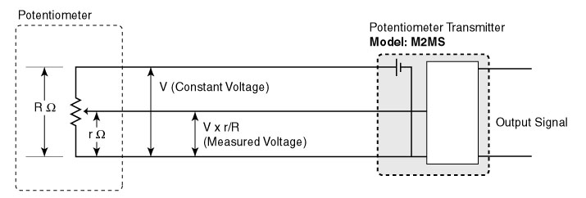
M-System has flexible solutions to meet your specific application and requirements. Consult our Signal Conditioners Data Library. 

