
In ratio control, I need to change the ratio manually at the front of the panel.

Install a potentiometer with ratio scale on the panel. Connect its output to our Potentiometer Transmitter model PMS and then its output to Math Function Module model JF. This module multiplies the reference signal F₁ with the ratio signal K to get the target value F₂. With this system, you can change the ratio K manually with a potentiometer. (Refer to Figure below.)
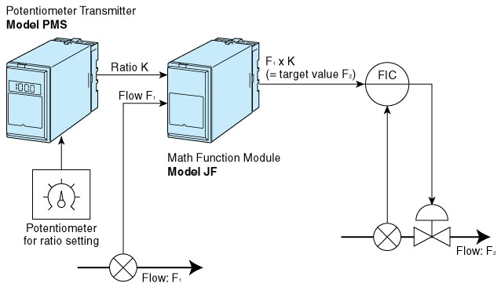
M-System has flexible solutions to meet your specific application and requirements. Consult our Signal Conditioners Data Library. 

