Automated Control of Inverter Frequency – Applying DC/Potentiometer Converter
An inverter is more often used now for selecting the drive frequency most adequate to an induction motor with a specific load. Frequency adjustment has generally depended on manual control of variable resistor – potentiometer – so far.
DC/Potentiometer Converter model CVR1 can easily automate this frequency adjustment. DC/Potentiometer Converter receives standardized instrument signals such as 4 to 20 mAdc and others to convert them into potentiometer resistance value such as 0 to 135Ω and 0 to 1kΩ. An inverter frequency control system employing the DC/Potentiometer Converter CVR1 is illustrated below:
DC/Potentiometer Converters CVR1 are used in certain cement companies for controlling frequency of inverters which drive mixer motors and others.
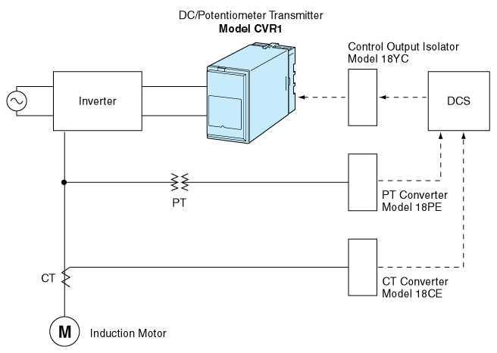
M-System has flexible solutions to meet your specific application and requirements. Consult our Signal Conditioners Data Library. 

