
Do you have a remote settable potentiometer?

Your requirement can be realized with our DC/Potentiometer Converter model CVR1 which accepts a DC current/voltage signal as input to provide a potentiometer resistance.
Operation of DC/Potentiometer Converter (model: CVR1): A servo motor built in CVR1 revolves according to the input. At the same time, a slidewire of the potentiometer connecting directly with the motor follows the motor operation. Then the potentiometer output is provided corresponding to the input.

Specifications
Input: various DC current or voltage signal
Output: potentiometer, 135Ω, 100Ω, 200Ω, 500Ω, 1kΩ, 2kΩ, 5kΩ, 10kΩ, 20kΩ, 50kΩ, or 100kΩ
Power input: 85 – 132V AC
Construction: plug-in
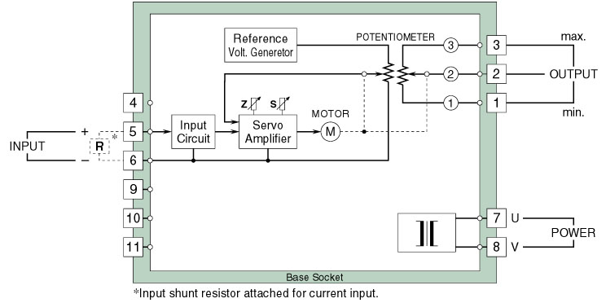
Circuit diagram of model CVR1
You can use CVR1 in the following application:
Long time signal hold (memory): When the power input of CVR1 is turned OFF, the build-in servo motor completely stops. Since this status is held until the power is turned ON, the input signal at power OFF is held as potentiometer resistance value. Connect this potentiometer value to our Potentiometer Transmitter (model: PM/PMS) to convert into a DC signal, and it works as long time signal memory device in a control loop (Refer to Figure).
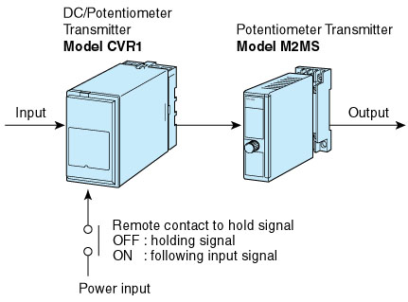
M-System has flexible solutions to meet your specific application and requirements. Consult our Signal Conditioners Data Library. 

