
I am looking for a signal conditioner which can output either 0 or 10 Vdc by switching ON-OFF contact.

You can use the Potentiometer Transmitter model M2MS.
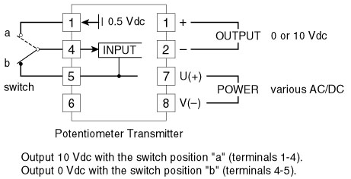
See Figure 1. The Potentiometer Transmitter has a built-in excitation voltage source of 0.5 Vdc. When the switch is turned to the side “a”, 0.5 V is input to the transmitter, while it’s turned to the side “b”, 0 V is input. Now if you choose the transmitter output 0-10 V, it provides 10 V for the “a” and 0 V for the “b”.
You can have other signals like 4 mA and 20 mA by choosing other output ranges.
Figure 1
Advanced Application: Advantages of utilizing potentiometers are their low cost and variety of types. By combining a 5-position rotary switch and five (5) potentiometers, you can have five (5) different analog signals with one (1) Potentiometer Transmitter. Connection diagram is shown in Figure 2 and relation of switch positions and output signals is shown in Figure 3.
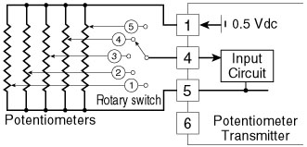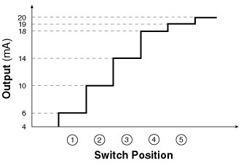
Figure 2 Figure 3
How To Determine Output Signal: Suppose you have a 1 kΩ potentiometer for the above example. The resistance value for switch position No. 4 is given as 875Ω with the following equation:
V1 = 0.5V x {(18-4) / (20-4)}
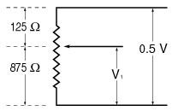
V1 = 0.4375 (Vdc)
V1 = 0.4375 V equals 87.5% of the range 0-0.5 V, which equals 875Ω for the range 0-1 kΩ. {(18-4 mA) / 16 mA x 100 = 87.5%}
Figure 4
M-System has flexible solutions to meet your specific application and requirements. Consult our Signal Conditioners Data Library. 

