
I want to measure variation of a signal and to alarm when the variation (deviation from the initial value) exceeds a certain value.
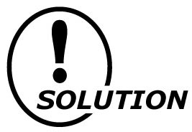
Your application can be realized with our Track/Hold models AM/AMS and Deviation Alarm model AYDV (Refer to the Figure 2).
Connection and alarm trip operation:
When the hold terminals (terminal No. 5 and 6) of Track/Hold models AM/AMS are ON (shortcircuited), output follows proportionally to the input. When they are OFF (open), the output at the point of command is held. Then connect this signal (2) at the time t ₀ when the signal is held and the input signal (1) to the input terminals of Deviation Alarm model AYDV. When the signal deviation between the signals (1) and (2) exceeds the preset range, the Deviation Alarm provides an alarm output (Refer to the Figure 3).
Application:
If you limit the hold time of signal (2), the Deviation Alarm works as variation factor alarm.
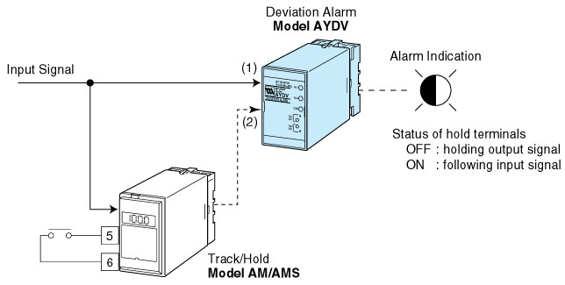Figure 1
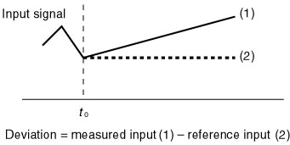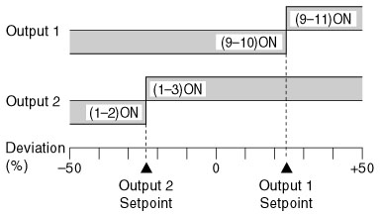
Figure 2 Figure 3

