
I want to have an alarm when the temperature difference in two (2) measuring points exceeds the preset range. I need to distinguish positive temperature difference (deviation) from negative deviation.

Use our Deviation Alarm model AYDV. Convert the temperature signals in 2 points into standard DC signals, and connect them with the Deviation Alarm. It accepts one of the signals as reference input and another as measured input, and outputs an alarm when the measured input is smaller than the reference input (negative deviation) or larger (positive deviation) and each deviation exceeds respective setpoint value. If you connect 2 outputs with an OR circuit, the same alarm output for both negative and positive deviations can be provided (Refer to the Figure).
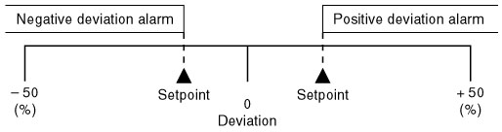
Figure : Alarm trip operation of Deviation Alarm
M-System has flexible solutions to meet your specific application and requirements. Consult our Signal Conditioners Data Library. 

