ON/OFF Pump Control – application of the model AS4V
You have a pump being controlled with an ON/OFF output of a single relay contact. A level sensor is being used as the feedback element for the pump control which is supplying a 4-20 mAdc output. You want the relay to shut the pump off when the level increases enough to reach 70% of full-scale (15.2 mAdc output from the level sensor). The pump is not to turn on again until the level decreases enough to reach 10% of full-scale (5.6 mAdc output from the level sensor).
In order to turn the control relay ON and OFF at these different points, a DC Alarm unit model ACV can be used. Conventional DC alarm units have only a limited hysteresis (deadband) adjustment capability with a maximum of 2%. However, the model ACV provides an adjustable wide-range hysteresis (deadband) adjustment from 1 to 99 % of the full-scale input range as a standard feature.
The standard model AS4V also provides dual setpoints (relay outputs) with independent hysteresis (deadband) adjustments and LED indicator lamps for both setpoint outputs.
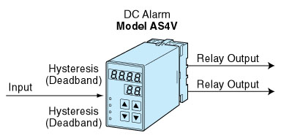
M-System has flexible solutions to meet your specific application and requirements. Consult our Signal Conditioners Data Library. 

