
I plan to monitor in an office valve travel installed in the field. Can I get four alarm contact signals (HH, H, L, LL) by just installing a pair of CVV cables between the field and the office?

Our 2-wire Position Transmitter model VOS2T-R realizes your application. The VOS2T-R converts position or angle signal into 4 – 20mA DC output proportional to it. Since the VOS2T-R is 2-wire, wiring is just a pair of cables between the filed and the office (Refer to the Figure).
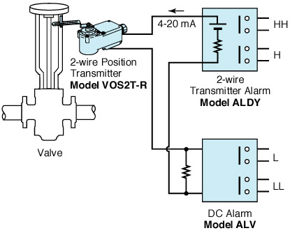
M-System has flexible solutions to meet your specific application and requirements. Consult our Signal Conditioners Data Library. 

