Smooth Tank Level Control by Staging Four Pumps
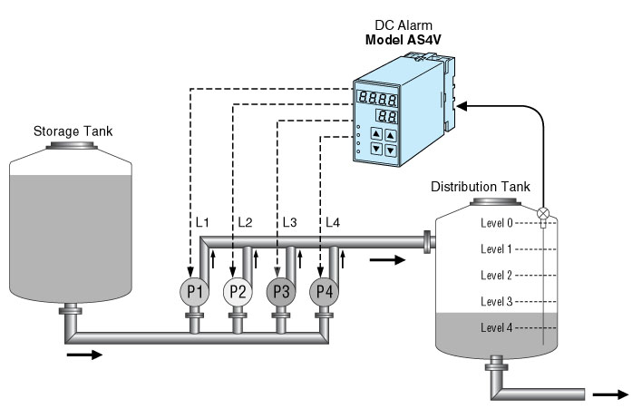
The Quad DC Limit Alarm model AS4V is suitable for controlling the level of a distribution tank in water treatment system.
See the figure as an example. When the distribution tank level is at “Level 3”, the output relay for L1, L2 and L3 are turned on so that the Pump 1 through Pump 3 work to provide water to the distribution tank.
This application uses for tanks instead of one very big pump. A big one is expensive and difficult to control its speed without using expensive equipment.
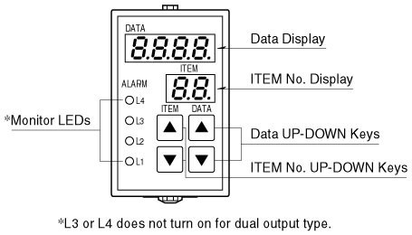
Furthermore, the AS4V has deadband (hysteresis) capability which can be programmed independently for each setpoint. Setting deadband for each control setpoint can eliminate unwanted pump cycling ON and OFF sporadically around the setpoint, even when the water level changes continuously.
We also have Temperature Input versions of AS4V: model AS4T, T/C input, and model AS4R, RTD input. T/C and RTD types are programmable, and setpoints can be specified in actual temperature unit.

M-System has flexible solutions to meet your specific application and requirements. Consult our Signal Conditioners Data Library. 

