Deviation Alarm for Water Level Difference and Driftage Separator Protection in Open Channels
Hydraulic power plants generally use intake screens in their open channels to prevent passage of driftage into water intakes. Most of the screens have driftage separators which automatically remove driftage accumulated around them (see Figure 1).
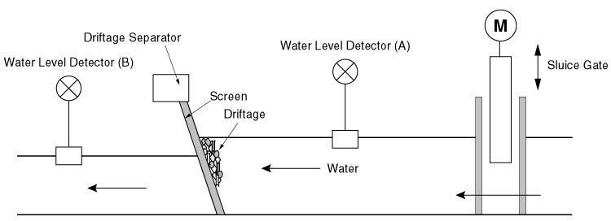
Figure 1: Driftage separation at the open channel water intake
A large piece of driftage such as driftwood, caught in the screen, may damage the driftage separator. Therefore the separator is usually designed to stop automatically in order to protect itself. In such extreme cases as above, a large difference in water level will be created between upstream and downstream of the screen. Then comparing both water level signals fed into the Deviation Alarm model AYDV, it provides an alarm signal when their difference exceeds the preset value. Even if the open channel is located far from the control center, alarm signals can easily be detected utilizing a Telemetering module model TMR.
With the dual alarm ability of the AYDV, after the first alarm, a second one could come into operation when the increased water level difference reaches a dangerous level, facilitating emergency measures including the shutdown of a sluice gate (see Figure 2).
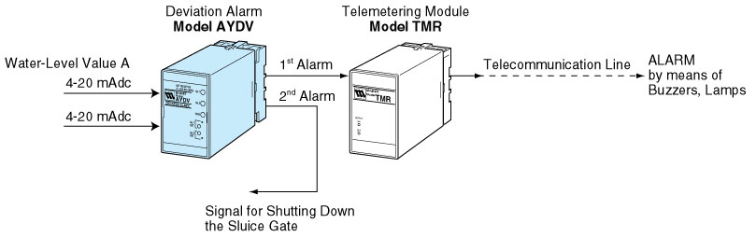
Figure 2: Alarm system by detecting the water level difference with the deviation alarm AYDV
Note: Besides the water level difference detection, the Deviation Alarm model AYDV may be used for detecting temperature difference or difference between any two signals.
M-System has flexible solutions to meet your specific application and requirements. Consult our Signal Conditioners Data Library. 

