M-Rester Application in Waterworks
All waterworks facilities in Japan are owned by municipal governments. Many years ago, one of them had many troubles because of lightning strikes in the vicinity. In their facility, there are many loops of water level control. They used the numerous process instruments such as level meter, and wirings that were exposed to the outside environment. Whenever lightning struck around the area many instruments were destroyed due to the surge caused by lightning.
As we got the information we visited the city and introduced our M-Rester. They were dubious about effects of the M-Rester regarding the surge protection. As you know it is very difficult to convince a government to use new products. However, after many visits, they installed our M-Rester on only several of their many many loops. When lightning struck around the are the next time, they were very surprised to find that the instruments protected by M-Rester were not destroyed while many other instruments on the loops which M-Rester were not installed were destroyed. This made them decide to install the M-Rester on all loops.
Fortunately this story was introduced in the Water Industrial Newspaper and distributed to all of city governments. After this many city governments who had trouble by lightning showed much interest in our M-Rester and our M-Rester has become a very known product at many waterworks facilities all over Japan.
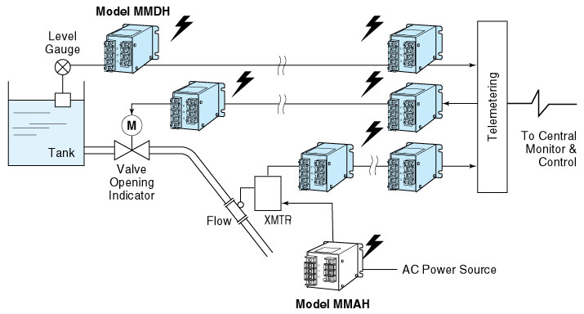
M-System has flexible solutions to meet your specific application and requirements. Consult our Signal Conditioners Data Library. 

