
We want to measure active power in 3-phase/3-wire, balanced system, with single current transformer, not two. Do you have a special unit for the purpose?

You can use the standard LTWT unit by supplying the current signal to both sets of current input terminals in parallel. The diagram shown is an example with the CT connected with Line 1. If the CT is connected to Line 3, you must use the signals 3S-3L and P2-P3.
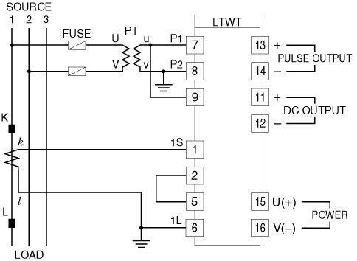
M-System has flexible solutions to meet your specific application and requirements. Consult our Signal Conditioners Data Library. 

