
What are the input waveform requirements when using average sensing vs. RMS sensing type current/voltage transducers?
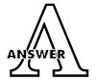
Average sensing and RMS sensing type transducers have different characteristics for distorted input waveforms.
When making your selection, refer to the following table and verify your input waveform.
SENSING TYPE | ACCURACY
Average | 3rd harmonic wave 15% : ±5%  SCR waveform*: ±15%
RMS | 3rd harmonic wave 15%: ±0.2%  SCR waveform*: ±0.5%
*SCR (Silicon Controlled Rectifier) Waveform
It is recommended that you use the auxiliary-powered type transducers when the input signals have special waveform characteristics.
This is due to the fact that a self-powered transducer uses input signal voltage for driving its internal electronic circuitry. Special waveforms may not provide enough energy even when the signal level is within the described operational range.
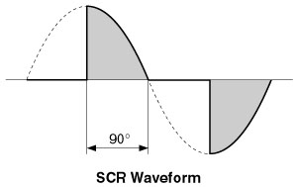
M-System has flexible solutions to meet your specific application and requirements. Consult our Signal Conditioners Data Library. 

