
M-System’s Power Transducers have no earth ground connection terminal. Why is this?

M-System’s Power Transducers employ miniature transformers (CT and PT transformers) in their internal circuitry in order to provide signal isolation between the primary and secondary circuits.
These internal transformers are able to reduce a surge impulse voltage (1.2/5 μsec. ±5kV) to less than one-fifteenth without requiring a static shield.
In order to protect the transducers and their receiving instruments from lightning surge voltages which can enter through the cables between them, we recommend that a M-System Lightning Surge Protector, M-RESTER series, be used.
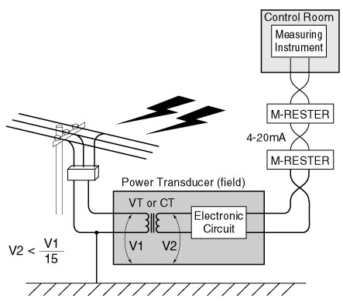
M-System has flexible solutions to meet your specific application and requirements. Consult our Signal Conditioners Data Library. 

