
I want to measure electric power with a power transducer to provide a pulse output. I have several points to measure power and CT/PT ratios differ depending on points. Also the actual load is not sure at the design stage. Do you have a transducer which can correspond to the change of CT or PT after installed and wired, and the pulse unit (Wh/pulse) of which can be set on site?

M-System’s Watt Transducer with pulse output model KUWT is suitable. As shown in the figure below, there are five rotary switches S1 to S5 on the front panel of the Watt Transducer, which are to adjust the pulse unit. The switches S1 to S4 are for 4-digit significant figures and S5 for a power, which adjust the max. rate for 100,000 pulses/h. Following is an example.
[Example] Model: KUWT-11_ _-_, 3-phase/3-wire, 110V/5A AC, 0 – 1000W, CT 60A/5A, PT 3300V/110V, pulse unit 1kWh/pulse. Determine max. pulses per hour first.
30 (PT ratio)×12 (CT ratio)/[(1kWh/pulse)÷1kW] = 360 pulses/h
Then the rate of 360 pulses per hour for 100,000 pulses/h is 360/1000,000 = 0.3600×10⁻². Therefore each switch should be adjusted as S1=3, S2=6, S3=0, S4=0 and S5=2.
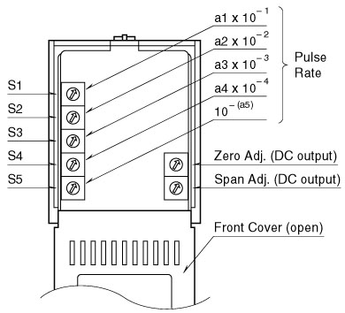
M-System has flexible solutions to meet your specific application and requirements. Consult our Signal Conditioners Data Library. 

