
We are planning to monitor AC current signal 0-5A from a current transformer (CT) on a personal computer.
Because the scanning time of personal computer is fast, we are looking for a fast-response type Power Transducer to meet the feature of this measurement target. Do you have any appropriate product?

M-System offers two types of CT transducer; one is Model CT, which has 0.5 sec. step response and another is model CTAF, which has 50 msec. step response.
For this application, we recommend to use the fast-response type CT Transducer model CTAF. Besides the CT Transducer, you can find other fast-response type Power Transducers such as the PT Transducer model PTAF and Watt Transducer model MEWTF in our products line.
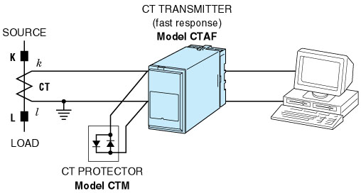
M-System has flexible solutions to meet your specific application and requirements. Consult our Signal Conditioners Data Library. 

