Bidirectional Current Transducer model LCY


What is this transducer used for? How is it different from normal AC current (CT) transducers like model LCE?

Normal AC current transducers can measure only the magnitude of input signal, like 0-5 A and 0-1 A.
Suppose you wish to measure AC current in a factory where the electricity is supplied from both power company and private power plant utilizing abundant internal heat generation. You may need to know not only the magnitude of the signal but the direction of it.
The model LCY detects phase angle in order to measure the direction of poer flow and outputs typically a positive or negative DC output.
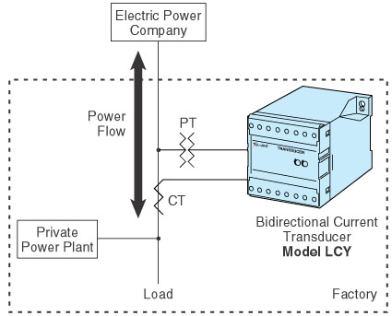
M-System has flexible solutions to meet your specific application and requirements. Consult our Signal Conditioners Data Library. 

