How To Get Two Pulse Outputs for Bidirectional Power?

My application is to accept bi-directional power (-1000 to 1000W) and to provide –10 to +10 Vdc output with pulse output. I want to have pulse output for both power consumption and power generation. But LT-Unit model LTWT can provide one pulse output only proportional to 0 to 1000W. How can I get another pulse also for 0 to –1000W?

Please use the LTWT and M2AP (DC/Frequency Converter). See the wiring diagram. DC output from the LTWT will be wired to the M2AP input in parallel. The point of this connection is to reverse the polarity so that the M2AP can provide 0 to 2.777 Hz output proportional to 0 to –10 V signal. Then you will get pulse outputs from LTWT for 0 to 1000W and from M2AP for 0 to –1000W.
You can also solve this problem by using two LTWT units to get two pulse outputs, but the wiring will be complicated.
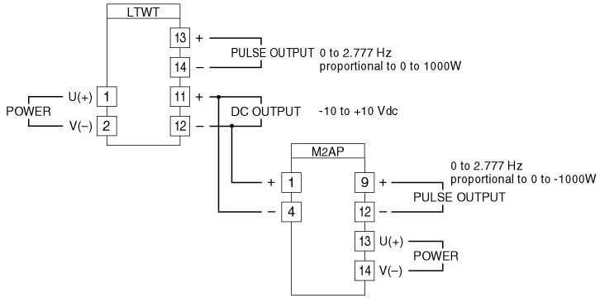
M-System has flexible solutions to meet your specific application and requirements. Consult our Signal Conditioners Data Library. 

