Factory Drainage pH Control System – applying Analog Positioner MEX
Concentration and amount of toxic materials contained in wastewater and gases discharged from factories are legally regulated for environmental reasons as commonly known. For example, in factories wastewater containing chemicals, the drainage pH is controlled through continuous measurement by throw-in type pH sensor installed in the drainage channels in order to meet these requirements.
The pH value is controlled by adjusting the amount of neutralizer feed, using metering pumps with electric servodevice. Analog Positioner MEX-C is used for controlling the pump flow via the electric servodevice, by comparing manipulated value signal from pH indicating controller and position signal from the electric servodevice.
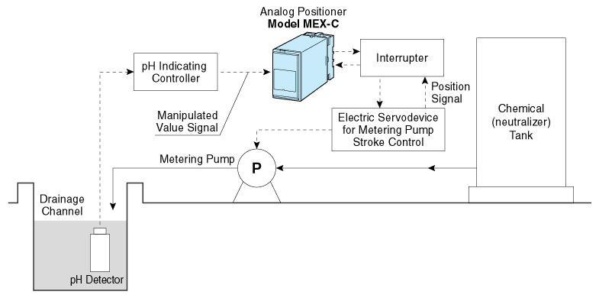
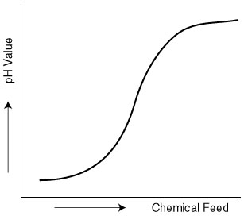
References for pH Control:
- The relation between the amount of chemical (neutralizer) feed and the pH value is non-linear, which can be represented by neutralization curve shown in the figure in the right side.
- The pH control generally has long dead time which may cause hunting while controlling. To avoid this effect, sampling control or control via an interrupter is used, compensating the dead time.

M-System has flexible solutions to meet your specific application and requirements. Consult our Signal Conditioners Data Library. 

