Chemical Feeder for Water Treatment – applying the Mini-top model MSP
Water purifying plants and water treatment facilities which take in river water or ground water and then produce clean water and industrial water, utilize various chemicals in order to neutralize, oxidize and deoxidize the original water in each process. It is important to keep the amount of these chemicals at the appropriate levels in order to comply with pollution control standards relative to the quantity of the original water. This control influences treatment efficiency, quality of clean and industrial water and their cost of treatment.
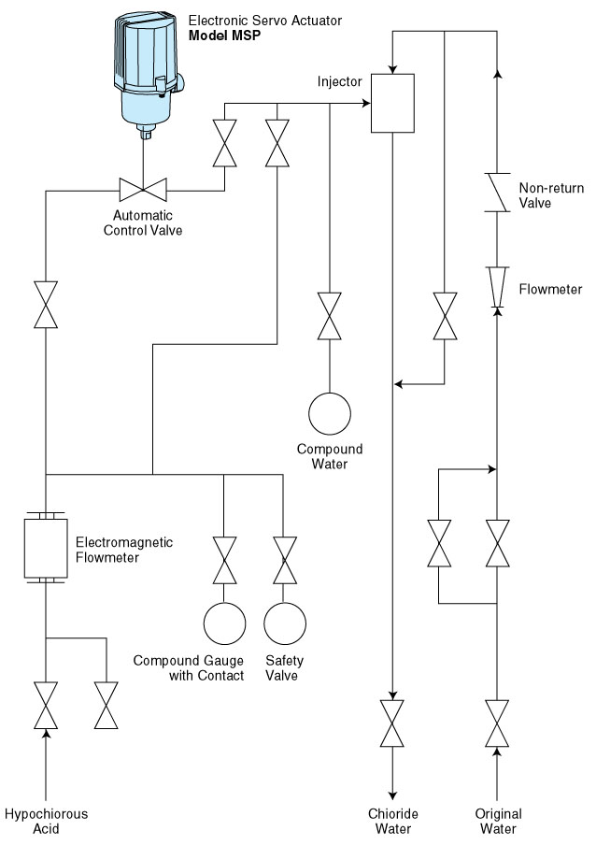
The illustration shows the flow chart of a hypochlorous acid feeding system as an example of chemical feeders used for disinfection, deodorization, and also removal of iron and manganese. The electromagnetic flowmeter, automatic control valve and the injector are all major components in this configuration. The M-System Mini-top is employed as an actuator for the automatic control valve which gives the following remarkable results:
- A compact and lightweight system
- No need for any air pressure supply
- Improved control performance
- Capability of monitoring the valve opening angle

M-System has flexible solutions to meet your specific application and requirements. Consult our Signal Conditioners Data Library. 

