Pulp Concentration Control System – applying the Mini-top model MRP
In recent years throughout the pulp and paper industry, pneumatic style measuring systems have been widely used. However, with the introduction of the electronic servo actuator, high precision, quick response and lower associated costs are definite benefits of the employment of electronic servo valves as control elements. The illustration below shows an example of a pulp concentration control system comprised of a pneumatic pulp concentration meter and the M-System Mini-top servo valve actuator.
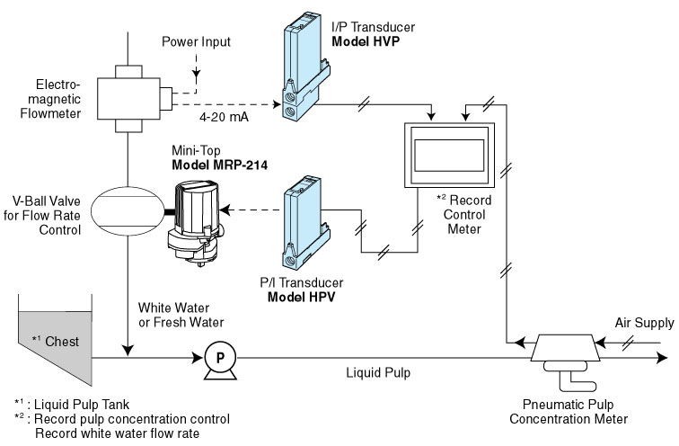
[Measuring Systems in the Pulp and Paper Industry]
The following are the reasons why pneumatic measuring systems have become common place in the pulp and paper industry:
- Users have confidence in the system based on long experience and an accumulation of “hands-on” know-how.
- Pneumatic systems have a lower associated initial cost than an electronic system.
The pneumatic measuring system has the following disadvantages:
- System requires an air supply plus an ever increasing maintenance cost.
- Piping work engineers are fewer than electrical engineers. Installation cost for piping is much higher for this reason.
Due to its high-reliability, electronic equipment tends to be utilized more and more in this type of application. This type of system also requires the use of P/I and I/P Transducers (see the illustration above).
M-System has flexible solutions to meet your specific application and requirements. Consult our Signal Conditioners Data Library. 

