Combustion Control of an Industrial Gas Burner – applying the Mini-top model MRP
Heating equipment utilizing industrial gas burners is becoming widely used because of their high burning efficiency and lack of noxious emissions. These include various kinds of dryers; hot air dryers, radiation heat type cloth dryers, paint dryers and other devices.
The burner is controlled by adjusting the supply rate of gas versus air, and the flow rate is controlled by a balancing relay type automatic control valve (control valves which open and close with the use of a required control performance because of the following reasons:
- It is rather heavy (10 to 30kg or 22 to 66 lbs) and difficult to handle
- Longer sampling time due to low motor response times
A recent field application (see the illustration below) has shown that by integrating the M-System Mini-top model MRP with an automatic control valve, some problems associated with conventional automatic control valves are eliminated and overall system performance is improved. It has also been reported in some cases that the temperature control accuracy was largely improved and the temperature variation was minimized to within 0.5℃ (0.9°F).
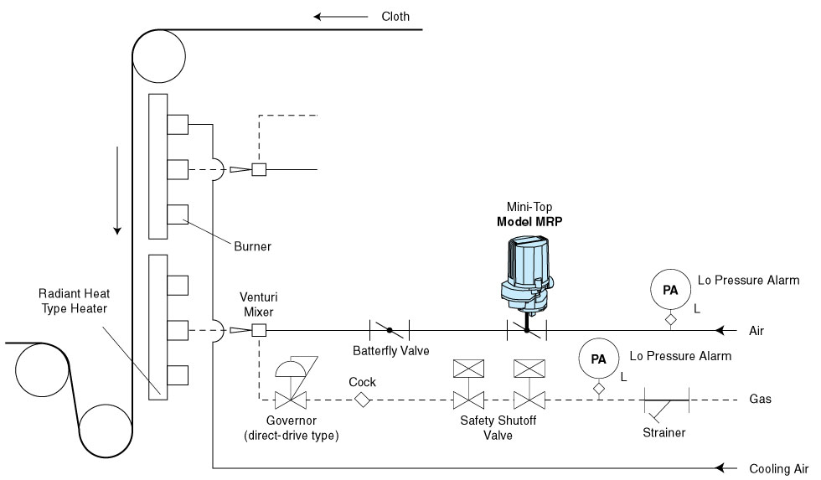
Approximately 100,000 sets per year of industrial burners, such as illustrated in the above example, including crude oil burners are installed just in Japan alone. This is therefore a large potential market for the Mini-top series.

Prospective customers
- Dryer manufacturers: cloth dryer for dye industry, paint dryer such as those used in automobile production line
- Burner manufacturers
- Heater manufacturers
- Gas companies (engineering groups for designing and planning of industrial gas burner systems)

M-System has flexible solutions to meet your specific application and requirements. Consult our Signal Conditioners Data Library. 

