M-System Mechatronics Series Application
■ Power Plant Control Valve Position Transmission: VOS unit
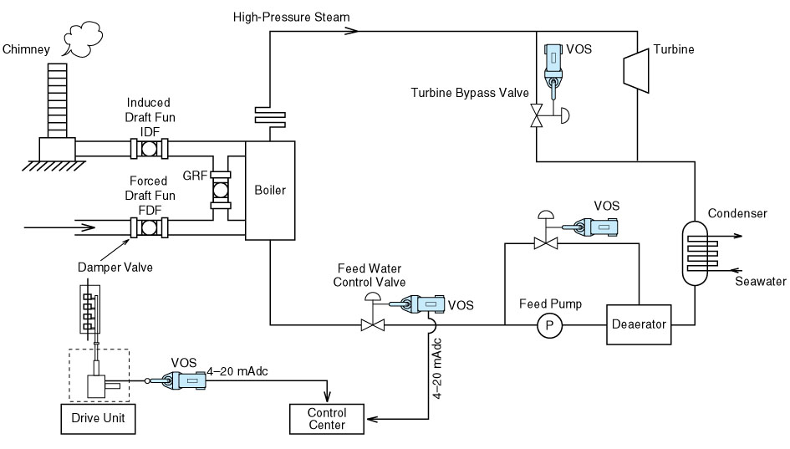
■ Water Purification Plants: Servo-Top II and Mini-top Series
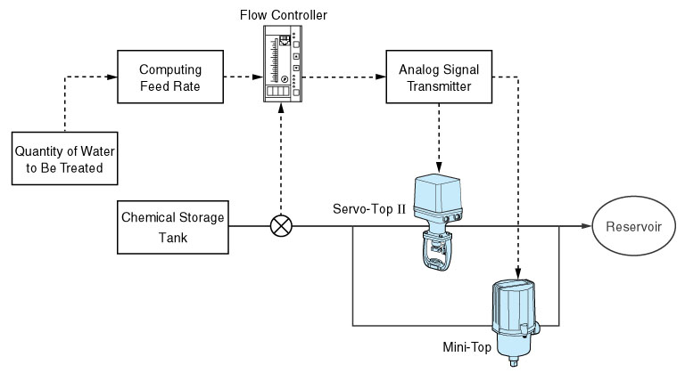
■ Marine Engine Cooling System: Servo-top C (rotary motion type)
M-System has flexible solutions to meet your specific application and requirements. Consult our Signal Conditioners Data Library. 

