
Why do we need to mount a CT protector model CTM on plug-in CT transducers?

When secondary side (input side of CT transducer) of a current transformer (CT) is open while current passes in the primary side, the CT tries to send current to the secondary side, which results in high voltage generated. To protect this dangerous situation, a small CT protector model CTM (dimensions: W22 × H9 × D19 mm or 0.87” × 0.35” × 0.75) is attached to the input terminals of the socket of M-System’s plug-in CT transducers. Even if you remove the transducer body from the socket, the secondary side of the CT is not open with CTM (Refer to the Figure).
A CT protector is not attached to rack-mounted CT transducers because of monolithic construction of the input terminals and the transducer body. Therefore always remember to check that current does not pass in the primary side of the CT in opening the input side of the CT transducer (secondary side of CT).
As for potential transformer (PT), there does not generate high voltage even in opening its secondary side (input side of PT transducer) and a protector is not necessary.
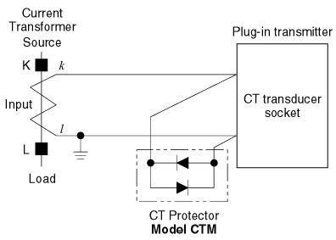
M-System has flexible solutions to meet your specific application and requirements. Consult our Signal Conditioners Data Library. 

