Computer Backup System – applying analog backup station
Along with the rapid development of computer technology and the decrease of its cost, as well as with improvement of its reliability, a great part of process control has become dependent on computer.
However, a computer cut-down by possible system failure may cause serious problems, and it is common to introduce certain backup system. One of the ways is to double-equip the system including CPU, yet an increased cost is not avoidable. For constructing a backup system at a lower cost, an application of Analog Backup Station model ABF is recommended. The Figure 1 shows the system configuration.
When the computer falls down, maintaining the latest operation outputs can prevent a sudden change of the valve travel.
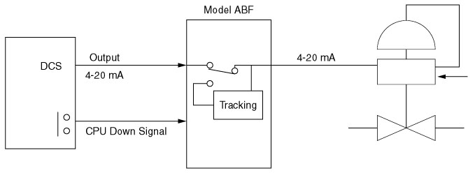
Figure 1
Meanwhile, an increased number of controlled items in the system may cause delay in detecting the computer cut-down, resulting a possible case that the operational output has already changed when the ABF receives the signal, such cases may be avoided by using Filter/Lag Transmitter model JFT2 as shown in the Figure 2.
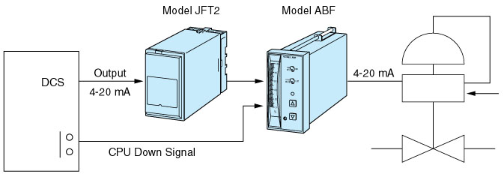
Figure 2
M-System has flexible solutions to meet your specific application and requirements. Consult our Signal Conditioners Data Library. 

