
I would like to install a manual station in the field as backup device of a controller. And I want the manual station to follow its input signal (output signal from host controller) with the preset response speed in switching manual operation to auto.

Manual backup in the field is one of the essential operation functions in test run in a plant, startup operation or maintenance, even in SPC (set point control), DDC (direct digital control), DCS (distributed control system) or a simple control loop. M-System’s Analog Backup Station model JB has a function that the output signal (MV output) of the Analog Backup Station shall follow the input signal (CAS input) instantaneously in switching the manual mode to the auto mode or slide the output gradually to CAS input (sliding-back), which can be specified freely with Programming Unit model: PU-2A.
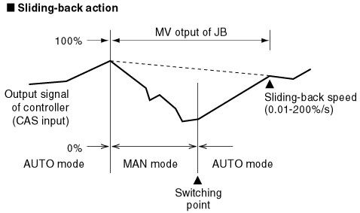
Sliding-back Action

- In sliding-back action, even if the CAS input (output signal of host controller) changes, the MV output of JB continues the sliding-back with the initial slope.
- When the MV output in sliding-back action of JB equals to the CAS input, JB turns on to the cascade operation, and the CAS input passes through at MV output terminals.
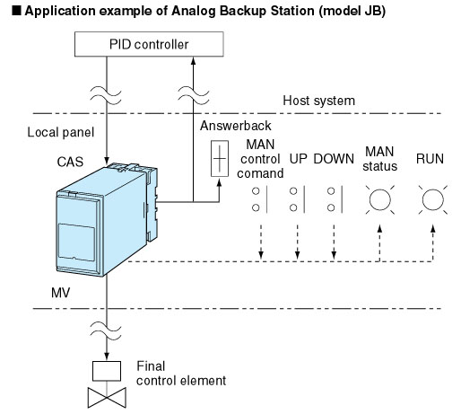
M-System has flexible solutions to meet your specific application and requirements. Consult our Signal Conditioners Data Library. 

