Single Point Telemetering
We had a customer needed to monitor just one tank level at a remote site, but had an extremely limited budget.
There was a leased copper line existed at the site, so the TMA modules were recommended to use. This allowed the customer to monitor this single point at a fraction of the cost of installing a data acquisition system, modem and receiving equipment at the master end.
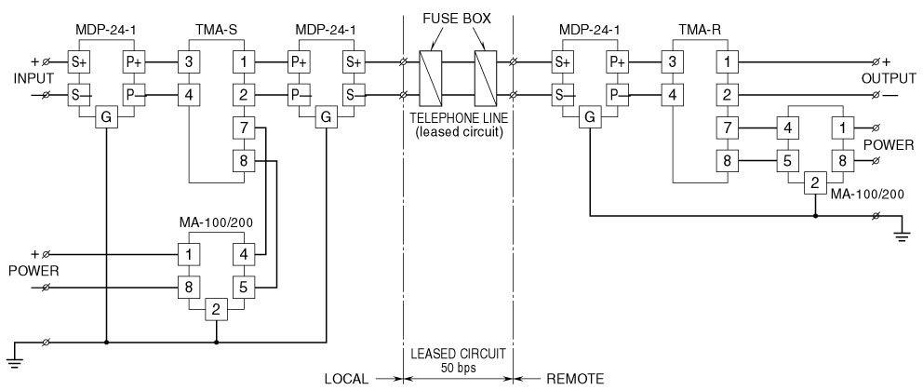
Recommended system configuration with lightning protection
M-System has flexible solutions to meet your specific application and requirements. Consult our Signal Conditioners Data Library. 

