Using the R1M in Conjunction with Citect5 – remote I/ O SCADA/HMI software package
Application example: Connection to a PC via RS232C
The SCADA software package Citect 5 produced by the Australian company Ci Technology includes as standard the necessary drivers for compatibility with Modicon’s Modbus open network communications protocol. The R1M unit communicates with a PC via the Modbus RTU protocol over a RS-232C or RS-485 cable and used in conjunction with Citect 5, the normally time-consuming setting of drivers is eliminated.
15 R1M units can be connected over a Modbus RTU (RS-485) twist pair network up to a maximum distance of 500m. Connection with the PC master can be made from any one of the 15 R1M units’ RS-232C communication ports, allowing the simple construction of a SCADA control system with 240 (16 channels x 15 modules) analogue channels.
When a PC cannot be connected within RS-232C cable range of any of the 15 R1M modules, the distance can be bridged by converting cabling to RS-485 via the R2K-1 model RS-232 to R2-485 conversion unit.
The R1M unit is not limited to only 16 channel analogue inputs. In fact, the R1M-D1 model can handle up to 32 contact outputs, allowing a simple alarm output interface for alarm conditions calculated within Citect itself.
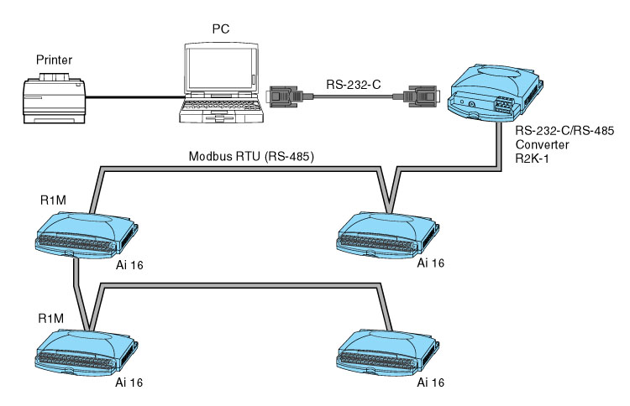
The following R1M modules are available:
- Thermocouple or DC input 16 channels: R1M-GH
- RTD or Potentiometer input 8 channels: R1M-J3
- Contact input 32 points: R1M-A1
- Contact output 32 points: R1M-D1

